IHM 5th grade Band Handbook
“Make a joyful noise unto the Lord, all you lands.” - Psalm 100:1

PURPOSE
The purpose of the Immaculate Heart of Mary Band Program is to enrich the lives of students at the school through the learning of the language of music and praising the Lord in all they do.

OBJECTIVES
1. To help students develop, through an emphasis on musical fundamentals, into the best musicians they can be.
2. To offer an opportunity for young musicians to perform literature of an appropriate difficulty, as part of a student ensemble.
3. To help students learn good character traits such as integrity, responsibility, self-discipline, and respect.
4. To help students learn cooperation with others and to work as “team” players to achieve group goals.
5. To promote, build, and educate future audiences and supporters of music.

MEMBERSHIP
A full year commitment is expected of all 5th grade Band students. Encouraging your child to finish something they started teaches them a valuable lesson that they can carry with them throughout their lives!

BAND EXPECTATIONS
- Arrive on time! Rehearsal times are Mondays 2:25-3:10pm; Wednesdays 1:15-2:00pm.
- Sit up straight.
- Keep both feet flat on the floor.
- Show active listening as the director(s) are at the front of the room.
- Respect your neighbor’s property and space.
- Raise your hand when you have a question or need help.
- Encourage one another!
- Have FUN! :)

BAND REHEARSALS
It is expected that every student bring the following to each rehearsal:
- Their instrument (reeds, cork grease, valve oil, etc.)
- Essential Elements 2000 Book 1
- Practice sheets (to be turned in at the beginning of class every Wednesday)
-Pencils are provided.
-Upon arrival to the band room, students are to put together their instruments at their seats. Larger cases for instruments are to be left in the corner of the room. Place your book and pencil on your music stand, turn in your practice sheet, then warm up quietly (scales, long tones, mouthpiece buzzing). Percussionists are to set up their bells/drums as quietly as possible.
-The start of rehearsal is signaled when the director comes to the podium at the front of the room.
-Gum chewing/food is not permitted in the classroom at any point (no one wants gum stuck in their instrument!!!!)
-Doing homework or anything not related to the rehearsal is not permitted during class.
-The director will signal the end of rehearsal, at which point students are to break down their instruments carefully, cleaning them out beforehand, and placing books back in the cases.
-Each member is responsible for the appearance of the room in his/her area. Your chair, music stand, and storage area should be clean at the end of rehearsal.

CONCERTS
5th Grade Band has 2 concerts this year:
- Christmas concert
Tentatively Tuesday, December 4th
IHM Gymnasium
Report time: 6:30pm
Concert Start: 7:00pm
- A “Bandtastic Celebration”
Daytime Rehearsal and Grades 5-12 Concert
Wednesday, March 27, 2019
Catholic Central Gymnasium
Report time: 6:30pm
Concert Start: 7:00pm

GRADING
For beginners, band grades are based on effort and improvement. Students can get behind easily with one or two missed class periods. Beginning band students will be required to keep track of practicing with a practice card that is provided. Also, at the end of the quarter, progress reports will be sent home to determine the progress your child is making. Letter grades are not given in Beginning Band.

PRACTICING
Parents are asked to reinforce practicing at home. With only two days a week of band class, it is very important that students practice at least 3-4 days a week in order to improve on their instrument. 15-20 minutes a session is recommended at first. Please remember to spread out practice times and try not to ‘cram’ everything into one sitting.
Parents are also to sign their student’s practice sheet each week the night before they are to turn in their forms. Please do not sign the sheet until it has been completed! Below is a sample of what the form will look like:
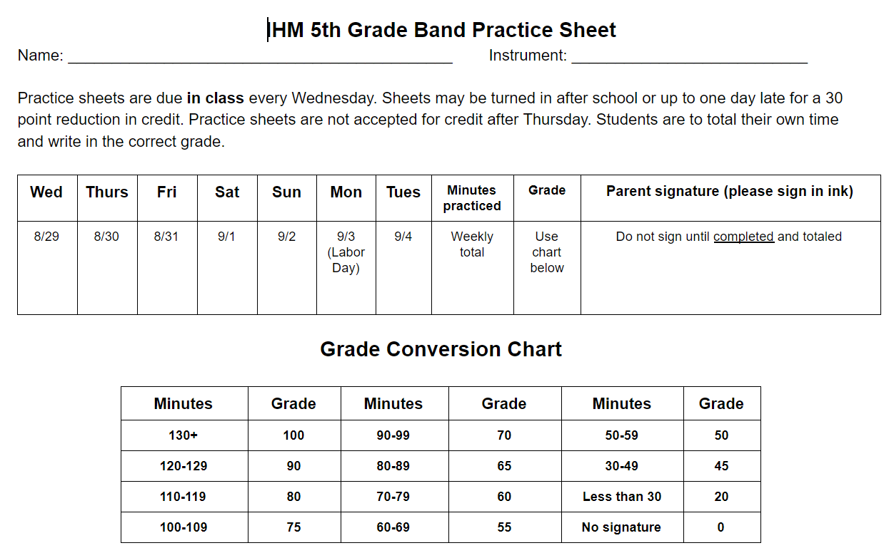

Throughout the year, if you have any questions or concerns, please feel free to contact me!

Quyen VanHouten
qvanhouten@ihmschoolgr.com

